Day 2 – Problem Solving Techniques and Data Structures – I
Set 1 – E-COMMERCE CATALOGUE
AND TRAFFIC ANALYSIS

Name | Parameswari K
Date | 30.10.2026
Tasks covered | - BST: insert, search, and inorder, preorder and postorder traversals for 15 categories  - Hash table: chaining, a collision demo, and a timing comparison against the built-in hash map for 100,000 SKUs  - Graph: deployment order using DFS (with a BFS note) and circular dependency detection  - Sliding window: busiest 3-hour window  - Two pointers: gift-card pairs

Task 1 – Binary Search Tree for Product Categories
A Binary Search Tree (BST) stores each category so that values smaller than a node go to its left and larger values go to its right. This supports efficient searching when the tree is reasonably balanced.
Sample categories inserted in this exact order (15): Electronics, Clothing, Books, Home, Beauty, Sports, Grocery, Mobiles, Laptops, Men, Women, Fiction, Furniture, Skincare, Outdoor.

BST structure
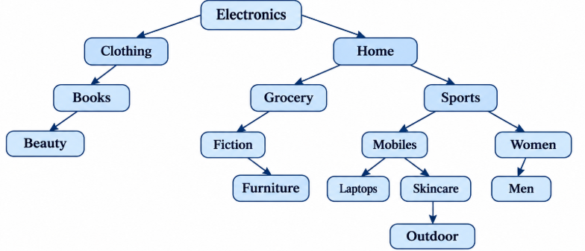

Node | Left child | Right child
Electronics | Clothing | Home
Clothing | Books | —
Books | Beauty | —
Beauty | — | —
Home | Grocery | Sports
Grocery | Fiction | —
Fiction | — | Furniture
Furniture | — | —
Sports | Mobiles | Women
Mobiles | Laptops | Skincare
Laptops | — | -
Men | — | —
Skincare | Outdoor | —
Outdoor | — | —
Women | Men | —

Pseudocode
INSERT(root, value):
IF root is NULL:
RETURN new Node(value)
IF value < root.value:
root.left = INSERT(root.left, value)
ELSE IF value > root.value:
root.right = INSERT(root.right, value)
RETURN root

INORDER(node):
IF node is not NULL:
INORDER(node.left)
PRINT node.value
INORDER(node.right)

PREORDER(node):
IF node is not NULL:
PRINT node.value
PREORDER(node.left)
PREORDER(node.right)

POSTORDER(node):
IF node is not NULL:
POSTORDER(node.left)
POSTORDER(node.right)
PRINT node.value

Sample output
Inorder (alphabetical order): Beauty → Books → Clothing → Electronics → Fiction → Furniture → Grocery → Home → Laptops → Men → Mobiles → Outdoor → Skincare → Sports → Women
Preorders:Electronics → Clothing → Books → Beauty → Home → Grocery → Fiction → Furniture → Sports → Mobiles → Laptops → Men → Skincare → Outdoor → Women
Postorder: Beauty → Books → Clothing → Furniture → Fiction → Grocery → Men → Laptops → Outdoor → Skincare → Mobiles → Women → Sports → Home → Electronics
Result: Inorder traversal of a BST returns the stored categories in sorted order. Average insert/search time is O(log n) for a balanced tree; worst case is O(n) for a skewed tree.

Task 2 – SKU Lookup Using Hashing
A hash table maps each SKU key to an array index. In this example, the hash function is the sum of the character codes modulo 5. Separate chaining stores multiple entries that map to the same index in a linked list (or bucket list).
Sample SKU keys: AB12, BA12, CD34, EF56. With the stated hash function, AB12 and BA12 demonstrate a collision because their character sums are equal.

Chaining example
HASH(sku):
total = 0
FOR each character ch in sku:
total = total + CODE(ch)
RETURN total MOD 5

INSERT(table, sku, product):
index = HASH(sku)
ADD (sku, product) to the bucket at table[index]

LOOKUP(table, sku):
index = HASH(sku)
FOR each (key, product) in table[index]:
IF key == sku:
RETURN product
RETURN NOT_FOUND

Illustrative bucket layout after inserting AB12, BA12, CD34 and EF56:
Bucket index | Stored SKU entries
0 | —
1 | —
2 | AB12 → Product A; BA12 → Product B (collision)
3 | CD34 → Product C
4 | EF56 → Product D

The bucket numbers above are an illustrative layout; the chosen hash function determines the actual index. The important collision-handling rule is that both colliding keys remain in the same bucket and are distinguished by comparing the full key.

Built-in hash map and 100,000 SKU comparison
skuMap = new HashMap()

FOR i = 1 TO 100000:
sku = "SKU" + STRING(i)
skuMap[sku] = productDetails(i)

START TIMER
REPEAT 10000 TIMES:
result = skuMap["SKU75000"]
STOP TIMER
PRINT elapsed time

For the custom chained table:
perform the same 10000 lookups using LOOKUP(table, "SKU75000")
measure elapsed time with the same machine and test data

Approach | Average lookup | Worst case | Notes
Custom hash table with chaining | O(1) | O(n) | Performance depends on hash quality, load factor and chain length.
Built-in HashMap | O(1) | O(n) in a general collision-heavy case | Usually highly optimized; implementation details depend on the language/runtime.

Expected comparison: both approaches have average constant-time lookup. A built-in HashMap is generally preferred in production because it is optimized and maintained by the language runtime. Exact milliseconds for 100,000 SKUs must be measured on the target machine; they should not be invented or treated as universal.
Benchmark fairness: use identical keys, identical lookup counts, warm up the runtime, repeat the test several times, and compare the average or median. Also test successful and unsuccessful lookups.

Task 3 – Microservice Dependencies as a Graph
Represent each microservice as a vertex. A directed edge A → B means service A depends on service B. Therefore, B must be deployed before A. The graph used here is:
Service | Depends on
Cart | Pricing
Pricing | Inventory
Checkout | Cart, Payment, Recommendation
Payment | Notification
Recommendation | Catalog
Catalog | Inventory
Inventory | None
Notification | None

Dependency graph
Checkout ──→ Cart ──→ Pricing ──→ Inventory
│
├──────→ Payment ──→ Notification
│
└──────→ Recommendation ──→ Catalog ──→ Inventory

BFS traversal from Checkout (visiting dependencies in the listed order): Checkout → Cart → Payment → Recommendation → Pricing → Notification → Catalog → Inventory.
DFS discovery order from Checkout (same neighbor order): Checkout → Cart → Pricing → Inventory → Payment → Notification → Recommendation → Catalog.
A valid deployment order is the reverse of DFS finishing order (dependencies first): Inventory → Pricing → Cart → Notification → Payment → Catalog → Recommendation → Checkout. This order respects every dependency edge.

Pseudocode – traversal, deployment order and cycle detection
BFS(graph, start):
create empty queue
mark start visited; enqueue start
WHILE queue is not empty:
node = dequeue
PRINT node
FOR each neighbor in graph[node]:
IF neighbor is not visited:
mark neighbor visited
enqueue neighbor

DFS_ORDER(node):
mark node visited
FOR each dependency in graph[node]:
IF dependency is not visited:
DFS_ORDER(dependency)
append node to finishList

deploymentOrder:
run DFS_ORDER for every unvisited service
REVERSE finishList

HAS_CYCLE(node):
mark node as ACTIVE
FOR each dependency in graph[node]:
IF dependency is ACTIVE:
RETURN true
IF dependency is UNVISITED AND HAS_CYCLE(dependency):
RETURN true
mark node as DONE
RETURN false

Cycle demonstration: add Inventory → Cart. The graph now contains Cart → Pricing → Inventory → Cart. Since the traversal reaches an ACTIVE node again, a circular dependency is detected.
Result: A valid deployment order can be generated only when the dependency graph is acyclic (a DAG). A cycle must be resolved before deployment planning.

Task 4 – Busiest Continuous 3-Hour Window
Given 24 hourly request counts, find the consecutive 3-hour period with the largest total. A sliding window calculates the first 3-hour sum, then moves one hour at a time by subtracting the outgoing value and adding the incoming value.
Sample requests per hour (Hour 1 to Hour 24): 120, 135, 128, 150, 170, 190, 210, 240, 260, 300, 280, 250, 230, 220, 210, 205, 195, 180, 175, 160, 150, 140, 130, 125.

Pseudocode
WINDOW_SUM = requests[0] + requests[1] + requests[2]
MAX_SUM = WINDOW_SUM
BEST_START = 0

FOR i = 3 TO 23:
WINDOW_SUM = WINDOW_SUM - requests[i - 3] + requests[i]
IF WINDOW_SUM > MAX_SUM:
MAX_SUM = WINDOW_SUM
BEST_START = i - 2

PRINT BEST_START, BEST_START + 2, MAX_SUM

Window calculation
3-hour period | Requests | Total
Hour 9–11 | 260 + 300 + 280 | 840
Hour 8–10 | 240 + 260 + 300 | 800
Hour 10–12 | 300 + 280 + 250 | 830

Sample output: Busiest window = Hour 9 to Hour 11; total requests = 840.
Result: The sliding-window method takes O(n) time and O(1) extra space. It is more efficient than recalculating every 3-hour sum from scratch.

Task 5 – Two Pointers for Gift-Card Pairs
The order values are already sorted. Place one pointer at the smallest value and another at the largest value. If their sum is too small, move the left pointer right; if it is too large, move the right pointer left. If the sum matches the gift-card value, record the pair and move both pointers.
Sample sorted order values: [10, 20, 30, 40, 50, 60, 70, 80, 90]. Gift-card value (target) = 100.

Pseudocode
FIND_PAIRS(values, target):
left = 0
right = LENGTH(values) - 1
WHILE left < right:
total = values[left] + values[right]
IF total == target:
PRINT values[left], values[right]
left = left + 1
right = right - 1
ELSE IF total < target:
left = left + 1
ELSE:
right = right - 1

Sample execution
Left value | Right value | Sum | Action
10 | 90 | 100 | Pair found
20 | 80 | 100 | Pair found
30 | 70 | 100 | Pair found
40 | 60 | 100 | Pair found

Sample output: (10, 90), (20, 80), (30, 70), (40, 60). The value 50 has no distinct partner because 50 + 50 would require using the same list position twice.
Result: The two-pointer technique takes O(n) time and O(1) extra space, excluding the output list. The input must be sorted; if it is not sorted, sort it first (O(n log n)).

Decision Table – Problem, Data Structure/Pattern and Reason
Task / Problem | Data structure or pattern | Why it is suitable | Time complexity
1. Insert, search and traverse 15 product categories | Binary Search Tree | Maintains ordered category data; inorder traversal produces sorted output. | Average O(log n) search/insert; worst O(n); traversal O(n).
2. SKU lookup and collision handling | Hash table with chaining; built-in HashMap | Maps SKU keys to buckets for fast average lookup; chaining preserves colliding entries. | Average O(1); worst O(n).
3. Microservice deployment dependencies | Directed graph; BFS, DFS and cycle detection | Models dependency relationships, finds traversal order and detects circular dependencies. | BFS/DFS/cycle detection O(V + E).
4. Busiest 3-hour traffic period | Sliding window | Reuses the previous window sum instead of summing each group again. | O(n) time; O(1) extra space.
5. Find pairs equal to gift-card value | Two pointers | Uses sorted order to move inward based on whether the current sum is low or high. | O(n) time; O(1) extra space.

Set 2 – Insurance Claims Processing
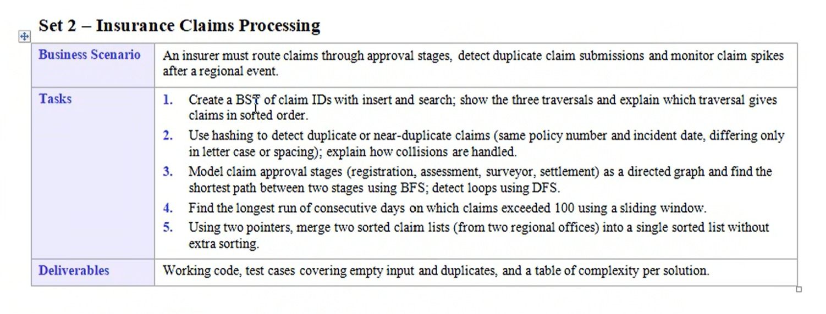

Task 1 – BST of Claim IDs
Claim IDs inserted in this order: 50, 30, 70, 20, 40, 60, 80, 35, 45, 65 (a repeated ID is ignored).

BST Diagram
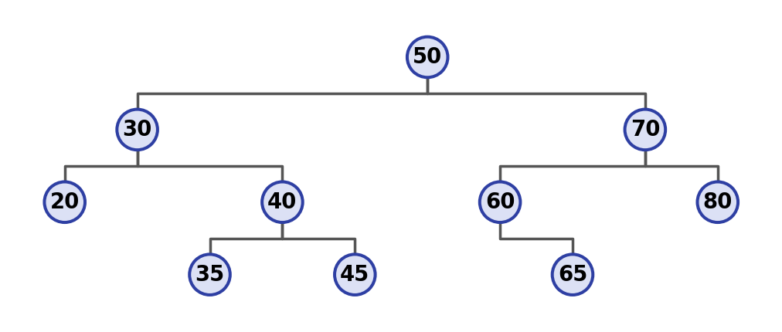
Pseudocode
CLASS Node: id, left = NULL, right = NULL
FUNCTION insert(node, id):
IF node is NULL: RETURN new Node(id)
IF id < node.id: node.left = insert(node.left, id)
ELSE IF id > node.id: node.right = insert(node.right, id)
// equal id = duplicate, do nothing
RETURN node
FUNCTION search(node, id):
IF node is NULL: RETURN "Not found"
IF id == node.id: RETURN "Found"
IF id < node.id: RETURN search(node.left, id)
ELSE: RETURN search(node.right, id)
inorder(n): IF n: inorder(n.left); PRINT n.id; inorder(n.right)
preorder(n): IF n: PRINT n.id; preorder(n.left); preorder(n.right)
postorder(n): IF n: postorder(n.left); postorder(n.right); PRINT n.id

Output
Inorder : 20 30 35 40 45 50 60 65 70 80
Preorder : 50 30 20 40 35 45 70 60 65 80
Postorder : 20 35 45 40 30 65 60 80 70 50
search(45) -> Found
search(99) -> Not found
Inorder (Left, Root, Right). It visits all smaller IDs first, then the root, then the larger IDs, so claims come out in ascending order. Preorder is used to copy a tree and postorder to delete one.

Task 2 – Duplicate Claim Detection (Hashing)
Idea: clean each claim (remove spaces, make capital letters), join policy number and incident date into one key, and store the key in a hash table. If the key already exists, the claim is a duplicate.
Pseudocode
SIZE = 3
table = array of SIZE empty lists
FUNCTION makeKey(policy, date):
policy = REMOVE all spaces from policy
policy = UPPERCASE(policy)
RETURN policy + "|" + date
FUNCTION hash(key):
RETURN (sum of ASCII values of key) MOD SIZE
FUNCTION checkClaim(policy, date):
key = makeKey(policy, date)
index = hash(key)
IF key is in table[index]: // compare full key inside the chain
PRINT "DUPLICATE"
ELSE:
ADD key to table[index] // chaining
PRINT "NEW"
Output
Claim Key Index Result
POL1001 , 2026-03-10 POL1001|2026-03-10 0 NEW
pol 1001 , 2026-03-10 POL1001|2026-03-10 0 DUPLICATE
POL2002 , 2026-03-11 POL2002|2026-03-11 0 NEW (collision)
Pol1001 , 2026-03-12 POL1001|2026-03-12 2 NEW
POL 2002 , 2026-03-11 POL2002|2026-03-11 0 DUPLICATE
Index 0 : [POL1001|2026-03-10] -> [POL2002|2026-03-11]
Index 2 : [POL1001|2026-03-12]

How collisions are handled
Two different claims can land in the same index (here POL1001 and POL2002 both go to index 0). We use chaining: each index holds a list, so both keys are stored together. When checking, we compare the full key with each item in that list, so a collision never gives a wrong duplicate result.

Task 3 – Claim Approval Stages (Graph)
Each stage is a node and each arrow means “can move to the next stage”. Settlement can be reached directly from Assessment for small claims, and Surveyor can send a claim back to Assessment for re-assessment.

Graph Diagram
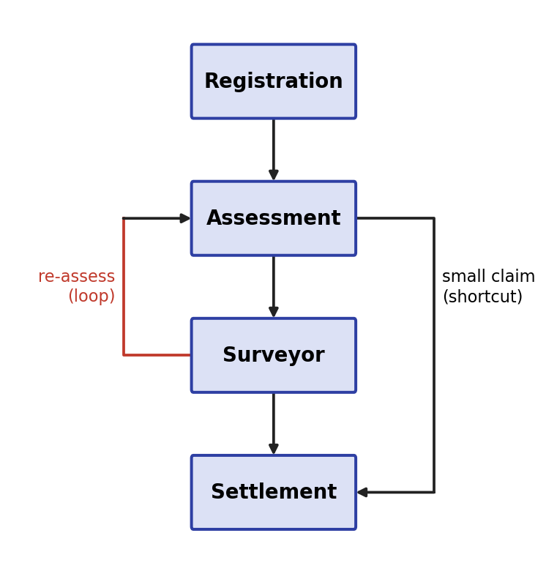
Pseudocode – Shortest path using BFS
FUNCTION bfs(start, end):
queue = [ [start] ] // queue of paths
visited = {start}
WHILE queue is not empty:
path = REMOVE first from queue
last = last stage in path
IF last == end: RETURN path
FOR each next in graph[last]:
IF next not in visited:
ADD next to visited
ADD (path + next) to queue
RETURN "No path"
Pseudocode – Loop detection using DFS
state[stage] = 0 (new), 1 (on current path), 2 (finished)
FUNCTION dfs(u):
state[u] = 1
FOR each v in graph[u]:
IF state[v] == 1: PRINT "Loop found"
ELSE IF state[v] == 0: dfs(v)
state[u] = 2
Output
Shortest path (Registration -> Settlement):
Registration -> Assessment -> Settlement (2 steps)
Loop detected: Assessment -> Surveyor -> Assessment

Task 4 – Longest Run Above 100 Claims (Sliding Window)
Pseudocode
INPUT: claims[1..n]
left = 1; best = 0; bestStart = 0
FOR right = 1 TO n:
IF claims[right] <= 100:
left = right + 1
ELSE IF (right - left + 1) > best:
best = right - left + 1
bestStart = left
PRINT best, bestStart, bestStart + best - 1
Output (sample data)
Day : 1 2 3 4 5 6 7 8 9 10 11 12 13 14
Claims : 80 120 130 90 110 140 150 160 95 105 101 99 102 103
Longest run above 100 : 4 days (Day 5 to Day 8)

Task 5 – Merge Two Sorted Lists (Two Pointers)
Pseudocode
INPUT: A[] and B[] (both sorted)
i = 0; j = 0; result = empty list
WHILE i < length(A) AND j < length(B):
IF A[i] <= B[j]: ADD A[i] to result; i = i + 1
ELSE: ADD B[j] to result; j = j + 1
WHILE i < length(A): ADD A[i] to result; i = i + 1 // leftover of A
WHILE j < length(B): ADD B[j] to result; j = j + 1 // leftover of B
PRINT result
Output (sample data)
Office 1 : 101 105 110 120
Office 2 : 102 106 115
Merged : 101 102 105 106 110 115 120

Test Cases (Empty Input and Duplicates)
Task | Test | Input | Expected Output
1 | Empty tree | No claim IDs | Traversals print nothing; search returns Not found
1 | Duplicate ID | Insert 40 twice | 40 stored once
2 | Empty list | No claims | No output, table stays empty
2 | Near duplicate | POL1001 and pol 1001, same date | Second claim marked DUPLICATE
3 | Same stage | Registration to Registration | Path = Registration (0 steps)
3 | No path | Settlement to Registration | No path
4 | Empty days | No data | Run = 0 days
4 | All below limit | 90, 80, 100 | Run = 0 days
5 | Both empty | [] and [] | []
5 | Duplicates | [3,3,5] and [3,4] | [3,3,3,4,5]
Test cases were checked by running the logic on these inputs.

Complexity Table
n = number of items, V = stages, E = arrows, m and n = list sizes.
Solution | Time | Space | Note
BST insert / search | O(log n) average, O(n) worst | O(n) | Worst case when IDs arrive sorted
Traversals | O(n) | O(h) stack | h = height of tree
Hash duplicate check | O(1) average per claim | O(n) | Worst O(n) if all keys collide
BFS shortest path | O(V + E) | O(V) | Finds fewest steps
DFS loop detection | O(V + E) | O(V) | Uses recursion stack
Sliding window | O(n) | O(1) | Single pass
Two-pointer merge | O(m + n) | O(m + n) | Space is for the merged output

SET 3 -Logistics Network and Delivery Windows
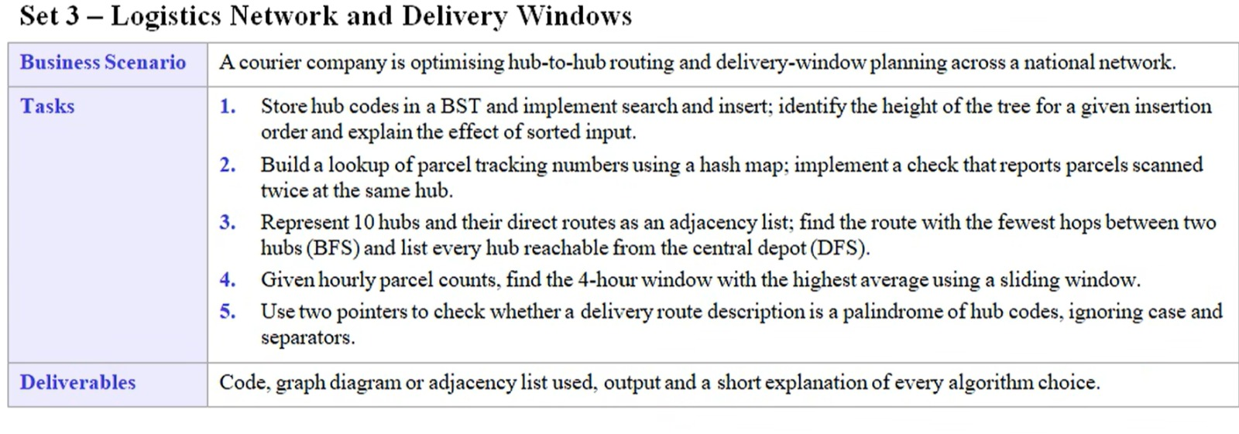
Task 1 – BST of Hub Codes
Hub codes inserted in this order: MUM, DEL, LKO, BLR, CHE, HYD, PUN, AHM.
BST Diagram
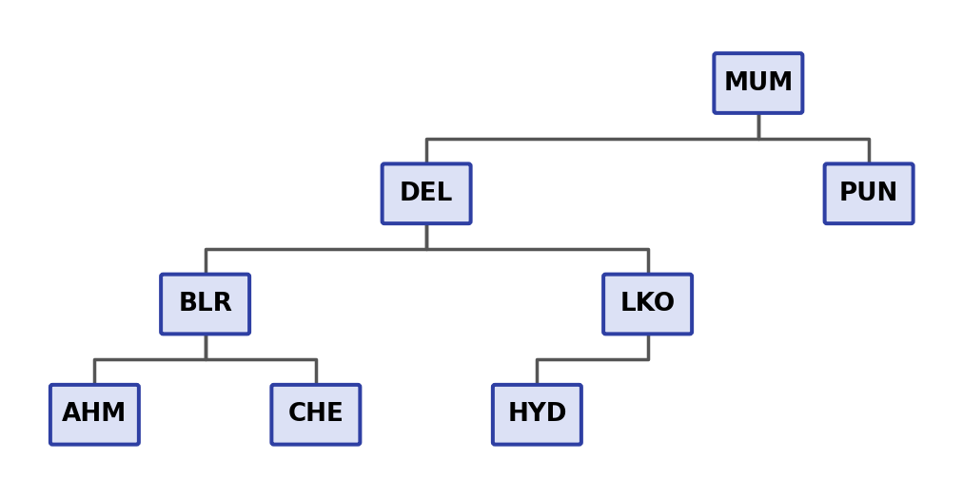
Alphabetically smaller codes go left, larger codes go right
Pseudocode
CLASS Node: code, left = NULL, right = NULL
FUNCTION insert(node, code):
IF node is NULL: RETURN new Node(code)
IF code < node.code: node.left = insert(node.left, code)
ELSE IF code > node.code: node.right = insert(node.right, code)
RETURN node

FUNCTION search(node, code):
IF node is NULL: RETURN "Not found"
IF code == node.code: RETURN "Found"
IF code < node.code: RETURN search(node.left, code)
ELSE: RETURN search(node.right, code)

FUNCTION height(node):
IF node is NULL: RETURN 0
RETURN 1 + MAX(height(node.left), height(node.right))
Output
Insertion order : MUM, DEL, LKO, BLR, CHE, HYD, PUN, AHM
Height of tree : 4
search(HYD) : Found
search(GOA) : Not found

Sorted insertion order : AHM, BLR, CHE, DEL, HYD, LKO, MUM, PUN
Height of tree : 8
Effect of sorted input
When hub codes arrive already sorted, every new code is larger than the last, so it always goes to the right. The tree becomes a straight chain (like a linked list) with height 8 instead of 4.
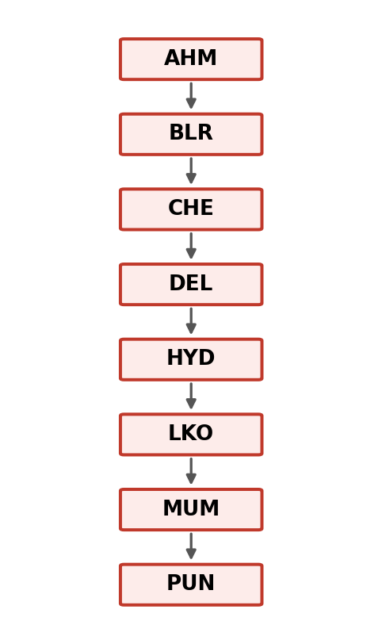
BST built from sorted input
Search then needs to check every node, so it slows from O(log n) to O(n). Inserting in a mixed order, or using a self-balancing tree (AVL / Red-Black), avoids this.
Why BST: it keeps hub codes ordered, so search and insert are fast when the tree is balanced.
Task 2 – Parcel Lookup and Double-Scan Check (Hash Map)
Idea: one hash map stores the last known hub of each tracking number (instant lookup). A second map counts scans using the key “tracking number @ hub”. When a count reaches 2, the parcel was scanned twice at the same hub.
Pseudocode
lastHub = empty HashMap // trackingNo -> hub
scanCount = empty HashMap // "trackingNo@hub" -> count

FUNCTION scan(trackingNo, hub):
lastHub[trackingNo] = hub
key = trackingNo + "@" + hub
scanCount[key] = scanCount.get(key, 0) + 1
IF scanCount[key] == 2:
PRINT "Parcel", trackingNo, "scanned twice at", hub

FUNCTION lookup(trackingNo):
IF trackingNo in lastHub: RETURN lastHub[trackingNo]
RETURN "Not found"
MAIN:
FOR each (trackingNo, hub) in scan log: scan(trackingNo, hub)
Output (sample scan log)
Scans: (TRK101,DEL) (TRK102,MUM) (TRK101,DEL) (TRK103,LKO)
(TRK101,MUM) (TRK102,MUM) (TRK104,DEL)

Parcel TRK101 scanned twice at DEL
Parcel TRK102 scanned twice at MUM

lookup(TRK101) -> MUM
lookup(TRK999) -> Not found
TRK101 at MUM is not reported because that is its first scan at MUM; only repeats at the same hub count.
Why hash map: look-up and counting take O(1) on average, so even millions of scans can be checked in one pass.
Task 3 – Hub Network (Graph)
Adjacency List (10 hubs, 11 two-way routes)
DEL : JAI, AGR, LKO BLR : PUN, HYD, CHE
JAI : DEL, AHM HYD : AGR, LKO, BLR
AHM : JAI, MUM AGR : DEL, HYD
MUM : AHM, PUN LKO : DEL, HYD
PUN : MUM, BLR CHE : BLR
Graph Diagram
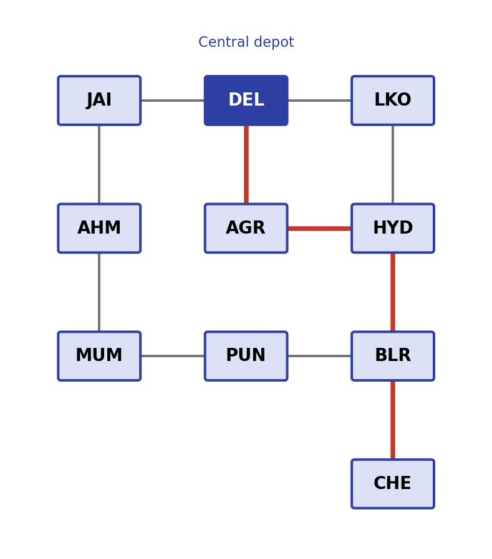
Hub network. DEL is the central depot; the red line is the fewest-hops route DEL to CHE
Pseudocode – Fewest hops using BFS
FUNCTION bfs(start, end):
queue = [ [start] ] // queue of routes
visited = {start}
WHILE queue is not empty:
route = REMOVE first from queue
last = last hub in route
IF last == end: RETURN route
FOR each next in graph[last]:
IF next not in visited:
ADD next to visited
ADD (route + next) to queue
RETURN "No route"
Pseudocode – Reachable hubs using DFS
visited = empty list

FUNCTION dfs(hub):
ADD hub to visited
FOR each next in graph[hub]:
IF next not in visited: dfs(next)

MAIN:
dfs("DEL")
PRINT visited
Output
Fewest hops DEL -> CHE : DEL -> AGR -> HYD -> BLR -> CHE (4 hops)
Fewest hops DEL -> PUN : DEL -> JAI -> AHM -> MUM -> PUN (4 hops)

Reachable from DEL (DFS) : DEL, JAI, AHM, MUM, PUN, BLR, HYD, AGR, LKO, CHE
Total reachable : 10 hubs (whole network)
Why adjacency list: it stores only the real routes, so it uses less memory than a 10 x 10 matrix and lists a hub’s neighbours quickly. Why BFS: it explores hub by hub, level by level, so the first route found has the fewest hops. Why DFS: it follows one route as deep as possible and visits every connected hub, which is all that is needed to list reachable hubs.
Task 4 – Best 4-Hour Window (Sliding Window)
Keep a window of 4 consecutive hours. Slide it one hour at a time: add the new hour, remove the oldest hour. Highest sum also means highest average, since the window size is fixed.
Pseudocode
INPUT: parcels[0..23] // parcels per hour
K = 4

windowSum = parcels[0] + parcels[1] + parcels[2] + parcels[3]
best = windowSum; bestStart = 0

FOR i = K TO 23:
windowSum = windowSum + parcels[i] - parcels[i - K] // slide
IF windowSum > best:
best = windowSum; bestStart = i - K + 1

PRINT bestStart, bestStart + K - 1, best / K
Output (sample data)
Hour : 0 1 2 3 4 5 6 7 8 9 10 11
Parcels: 40 35 30 28 25 30 60 120 180 210 190 170
Hour : 12 13 14 15 16 17 18 19 20 21 22 23
Parcels: 160 175 185 200 220 240 210 150 110 80 60 45

Best 4-hour window : Hour 15 to Hour 18 (15:00 to 18:59)
Parcels in window : 200 + 220 + 240 + 210 = 870
Highest average : 870 / 4 = 217.5 parcels per hour
Why sliding window: each slide is one add and one subtract, so the whole day is scanned once in O(n) instead of re-adding 4 values for every window.
Task 5 – Palindrome Delivery Route (Two Pointers)
A route reads the same forwards and backwards when the hub codes match from both ends. First clean the text: split it into hub codes at any separator (space, comma, dash, arrow) and make capital letters. Then compare from both ends.
Pseudocode
FUNCTION isPalindromeRoute(text):
codes = SPLIT text at every non-letter / non-digit character
REMOVE empty pieces from codes
CONVERT every code to UPPERCASE

left = 0; right = length(codes) - 1
WHILE left < right:
IF codes[left] != codes[right]: RETURN FALSE
left = left + 1; right = right - 1
RETURN TRUE
Output (sample routes)
Route description | Result | Reason
DEL > MUM > BLR > MUM > DEL | TRUE | DEL=DEL, MUM=MUM, BLR in the middle
Del, Mum , Pun,mum ,DEL | TRUE | Case and separators ignored
del-mum-blr-CHE-DEL | FALSE | MUM does not match CHE
DEL-MUM | FALSE | DEL does not match MUM
(empty route) | TRUE | Nothing to compare
Why two pointers: one pointer starts at each end and they move inward, so each hub code is checked once in O(n) with no reversed copy of the route needed.
Complexity Table
n = number of items, V = hubs, E = routes.
Solution | Time | Space | Note
BST insert / search | O(log n) average, O(n) worst | O(n) | Worst case with sorted input
BST height | O(n) | O(h) stack | h = height of tree
Hash map scan check | O(1) average per scan | O(n) | Two maps: last hub and counts
BFS fewest hops | O(V + E) | O(V) | Adjacency list
DFS reachable hubs | O(V + E) | O(V) | Recursion stack
Sliding window | O(n) | O(1) | Single pass
Two-pointer palindrome | O(n) | O(n) | Space for the cleaned list of codes

